**Determination of Optimum Entrainer for Extractive Distillation using Isovolatility Curve**

**Summary of the project:** The separation of azeotrope and close boiling mixtures is a challenge in most chemical processes. In recent years, many special techniques have been used for separating the azeotropic systems such as azeotropic distillation, pressure-swing distillation, extractive distillation.

**Pressure-swing distillation** is commonly used for carrying out the separation for pressure sensitive azeotropic mixtures.

**Extractive distillation** is most widely used technique for pressure-insensitive azeotropic mixtures.

The choice of the separation technology cannot depend only on the type of the separated mixture. Compared two methods, pressure-swing distillation and extractive distillation, for the separation of acetone-methanol and found that the extractive distillation process could save 15% more than the pressure-swing distillation process in the economy.

In the design process of extractive distillation, the choice of the entrainer is critical.

**Process design and economic analysis:** DWSIM open-source software was used to simulate extractive distillation for separating ethanol-benzene binary azeotropes. The thermodynamic models of the separation processes were validated using root mean square deviation. The thermodynamic model used to predict the values was UNIQUAC and NRTL.

The economics were evaluated in terms of TAC.

TAC($/year) = Annual operating costs + Capital costs/plant lifetime.

Annual operating cost = Steam costs (Reboiler) + Cooling water costs (Condenser)

Capital costs = Column vessel costs + Plate costs + Heat exchanger cost.

Due to the high equipment investment and high energy costs, optimization is necessary for most chemical engineering. We have used the software that is based on the sequential iterative optimization procedures and annealing algorithms, named Extractive Distillation Optimization Software (EDOS).

Table 1

|  |  |  |
| --- | --- | --- |
| System | Root mean square deviations |  |
|  | **UNIQUAC** | **NRTL** |
| Ethanol-benzene | 0.0157 | 0.0219 |
| Ethanol-1,2-propanediol | 0.0081 | 0.0078 |
| Ethanol-p-xylene | 0.0196 | 0.0203 |
| Benzene-p-xylene | 0.0200 | 0.0202 |

The EDOS optimization procedure consists of the following steps. First, some initial values and algorithms parameters are provided to the computer program, and then they are passed to simulation software as design variables for the process simulation. At the completion of the simulation, the results are transferred back to the computer program, which calculates the TAC, and the design variables are updated according to the optimization algorithm. The steps are repeated until a minimal TAC is obtained, and the optimal results can be found in the Microsoft Excel file that contains the optimal results. The design variables including the number of stages (NT1 NT2) in the extractive distillation column (C1) and the entrainer recovery column (C2), the feed locations (NF1 NF2), the entrainer feed location (NR) and the entrainer amount (Rrec) are optimized to obtain the minimum TAC.

* The purity of distillate in extractive distillation column is set at 99.5 mol% by varying the re flux ratio for the extractive distillation column.

**Case study 1: Ethanol-benzene**

**Process design and Optimization**

Ethanol and benzene are widely used as raw materials and solvents in chemical industry. The binary minimum azeotrope ethanol-benzene is formed with 44.8 mol % ethanol under 1 atm.

A preliminary screening of the solvents was carried out according to the dielectric constant. Several solvents dimethyl sulfoxide, 1,2-propanediol, chlorobenzene, and p-xylene were selected as candidate entrainers. Fig. 2 shows the effect of different entrainers on VLE of ethanol-benzene with an entrainer to feed mole ratio 1. According to the degree of deviation from the diagonal, the separation effects of 1,2-propanediol and p-xylene are studied.

**Fig. 1**. Effect of different entrainer on VLE of ethanol benzene

The fresh feed flowrate is 100 kmol/h with composition of 50 mol % of ethanol and 50 mol % of benzene, the entrainer feed flowrate is from 30 kmol/h to 150 kmol/h. The data can be calculated using Flash2 module in Aspen Plus, and the flash is operated at 1 atm and the duty is zero (adiabatic operation). By gradually adding entrainer into the system, the enhancement of the relative volatility of ethanol to benzene is calculated at di fferent entrainer to feed ratios (E/ F).

**Column 1:**

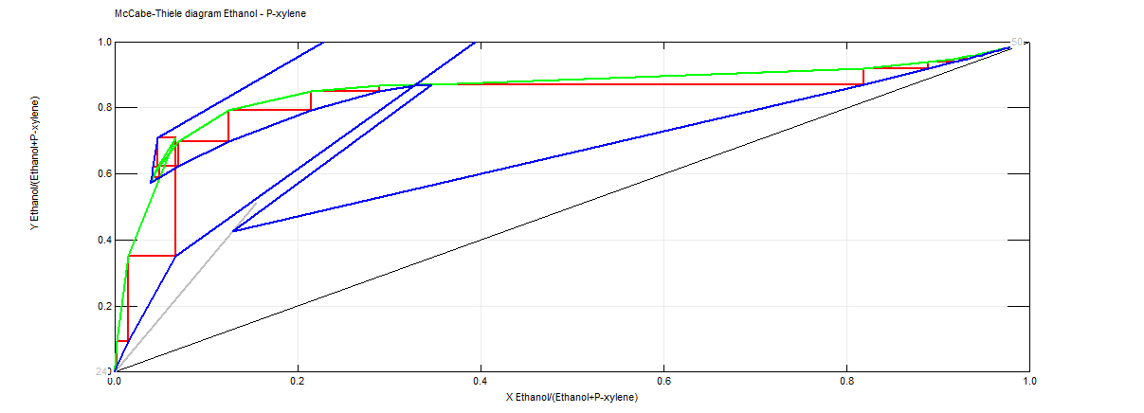

**Column 2:**

**Results.**

**Overall system flowsheet :**

**Fig.3**. Enhancement of relative volatility at 1 atm for ethanol-benzene by adding heavy entrainer 1,2 propanediol/p-xylene.

**Conclusion:**

In this work, azeotropic system ethanol-benzene were investigated by extractive distillation. Through the analysis of the isovolatility curve, we found that the isovolatility curve reached a different binary side with different entrainers. The location of the isovolatility curve determines which component is an attainable product and what the column configuration is. Software EDOS was used to optimize the processes of ethanol-benzene-1,2-propanediol/p-xylene. This study provides more insight for the selection of the entrainer, which is easily carried out.